Quiz – 4

**1) A feature F1 can take certain value: A, B, C, D, E, & F and represents grade of students from a college.**

**Which of the following statement is true in following case?**

A) Feature F1 is an example of nominal variable.  
B) Feature F1 is an example of ordinal variable.  
C) It doesn’t belong to any of the above category.  
D) Both of these

**2) Which of the following is an example of a deterministic algorithm?**

A) PCA

B) K-Means

C) None of the above

**3) [True or False] A Pearson correlation between two variables is zero but, still their values can still be related to each other.**

A) TRUE

B) FALSE

**4) Which of the following statement(s) is / are true for Gradient Decent (GD) and Stochastic Gradient Decent (SGD)?**

1. **In GD and SGD, you update a set of parameters in an iterative manner to minimize the error function.**
2. **In SGD, you have to run through all the samples in your training set for a single update of a parameter in each iteration.**
3. **In GD, you either use the entire data or a subset of training data to update a parameter in each iteration.**

A) Only 1

B) Only 2

C) Only 3

D) 1 and 2

E) 2 and 3

F) 1,2 and 3

**5) Which of the following hyper parameter(s), when increased may cause random forest to over fit the data?**

1. **Number of Trees**
2. **Depth of Tree**
3. **Learning Rate**

A) Only 1

B) Only 2

C) Only 3

D) 1 and 2

E) 2 and 3

F) 1,2 and 3

**6) Imagine, you are working with XYZ and you want to develop a machine learning algorithm which predicts the number of views on the articles.**

**Your analysis is based on features like author name, number of articles written by the same author in past and a few other features. Which of the following evaluation metric would you choose in that case?**

1. **Mean Square Error**
2. **Accuracy**
3. **F1 Score**

A) Only 1

B) Only 2

C) Only 3

D) 1 and 3

E) 2 and 3

F) 1 and 2

**7) Given below are three images (1,2,3). Which of the following option is correct for these images?**

|  |  |
| --- | --- |
|  |  |
|  |  |

A) 1 is tanh, 2 is ReLU and 3 is SIGMOID activation functions.

B) 1 is SIGMOID, 2 is ReLU and 3 is tanh activation functions.

C) 1 is ReLU, 2 is tanh and 3 is SIGMOID activation functions.

D) 1 is tanh, 2 is SIGMOID and 3 is ReLU activation functions.

**8) Below are the 8 actual values of target variable in the train file.**

**[0,0,0,1,1,1,1,1]**

**What is the entropy of the target variable?**

A) -(5/8 log(5/8) + 3/8 log(3/8))

B) 5/8 log(5/8) + 3/8 log(3/8)

C) 3/8 log(5/8) + 5/8 log(3/8)

D) 5/8 log(3/8) – 3/8 log(5/8)

**9) Let’s say, you are working with categorical feature(s) and you have not looked at the distribution of the categorical variable in the test data.**

**You want to apply one hot encoding (OHE) on the categorical feature(s). What challenges you may face if you have applied OHE on a categorical variable of train dataset?**

A) All categories of categorical variable are not present in the test dataset.

B) Frequency distribution of categories is different in train as compared to the test dataset.

C) Train and Test always have same distribution.

D) Both A and B

E) None of these

**10) Skip gram model is one of the best models used in Word2vec algorithm for words embedding. Which one of the following models depict the skip gram model?**

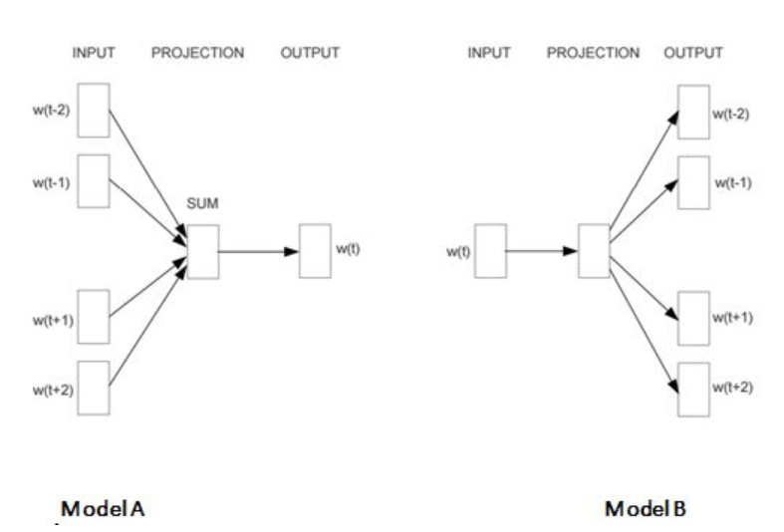

A) A

B) B

C) Both A and B

D) None of these

**11) Let’s say, you are using activation function X in hidden layers of neural network. At a particular neuron for any given input, you get the output as “-0.0001”. Which of the following activation function could X represent?**

A) ReLU

B) tanh

C) SIGMOID

D) None of these

**12) [True or False] LogLoss evaluation metric can have negative values.**

A) TRUE  
B) FALSE

**13) Which of the following statements is/are true about “Type-1” and “Type-2” errors?**

1. **Type1 is known as false positive and Type2 is known as false negative.**
2. **Type1 is known as false negative and Type2 is known as false positive.**
3. **Type1 error occurs when we reject a null hypothesis when it is actually true.**

A) Only 1

B) Only 2

C) Only 3

D) 1 and 2

E) 1 and 3

F) 2 and 3

**14) Which of the following is/are one of the important step(s) to pre-process the text in NLP based projects?**

1. **Stemming**
2. **Stop word removal**
3. **Object Standardization**

A) 1 and 2

B) 1 and 3

C) 2 and 3

D) 1,2 and 3

**15) Suppose you want to project high dimensional data into lower dimensions. The two most famous dimensionality reduction algorithms used here are PCA and t-SNE. Let’s say you have applied both algorithms respectively on data “X” and you got the datasets “X_projected_PCA” , “X_projected_tSNE”.**

**Which of the following statements is true for “X_projected_PCA” & “X_projected_tSNE” ?**

A) X_projected_PCA will have interpretation in the nearest neighbour space.

B) X_projected_tSNE will have interpretation in the nearest neighbour space.

C) Both will have interpretation in the nearest neighbour space.

D) None of them will have interpretation in the nearest neighbour space.